BIT 4107 – Mobile Application Development
ENHANCED PROFESSIONAL STUDENT LOGBOOK
Student Name: Julia Aywa
Admission Number: BIT/2024/73820
School/Faculty: Computing and informatics
Programme: Information Technology
Academic Year: 3
Semester: 2
Lecturer: Michael Nyoro
Phone Number:0791381457

Contents
Week 1: Introduction to Mobile Application Development 5
Hello world app 5
Code: 5
Output: 6
Assignment: New app with different features from hello world app 6
Code 6
Output: 7
Tools/Software Used 7
Personal Reflection 8
Week 2: Mobile Development Environment 9
Development of the mini-Student management app: 9
Code: 9
Output: 11
Tools /Software Used: 12
Personal Reflection 12
Week 3: User Interface Design 13
UI Design 13
Code 15
Output 18
Tools/software Used 21
Personal reflection 21
Week 4: Data Management 22
Entity Record Management 22
Code 22
Output 25
Tools/Software Used 27
Personal Reflection 27
Week 5: Networking and APIs 28
API 28
Code 28
Output 29
Tools Used 30
Personal reflection 30
Week 6: Networking 31
Internet connectivity 31
Code 31
Output 32
Tools used 32
Personal reflections 32
Week 7: Data storage and Database integration in mobile applications 33
Data storage 33
Code 33
33
33
Output 34
Tools used 35
Personal Reflection 36
Week 8: Handling User input and events 37
Input 37
Personal reflection 40
Week 9: Device Features and Sensors 41
Same as week 1 41
Week 10: Notifications and Background Services 42
Same as week 1 42
Week 11: Mobile Security 43
Same as week 1 43
Week 12: Testing and Debugging 43
Same as week 1 43
Week 13: Application Deployment 43
Same as week 1 43
Week 14: Final Project Presentation 43
Same as week 1 43
Semester Project Tracking 44
Project Title 44
Project Objectives 44
Project Requirements 44
Development Milestones 44
Testing Results 44
Lessons Learned 44
Future Improvements 44
End of Semester Reflection 45
Summary of Skills Acquired 45
Most Interesting Topic 45
Major Challenges Faced 45
How Challenges Were Overcome 45
Professional Growth Achieved 45
Overall Course Experience 45
Final Approval 45

Week 1: Introduction to Mobile Application Development

Hello world app

Code:
Fig 1:
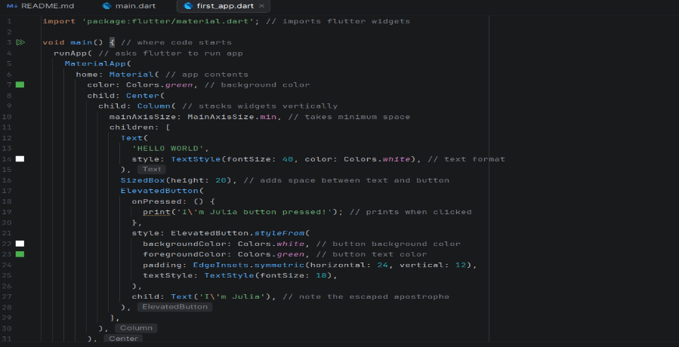

Output:
Fig 2:
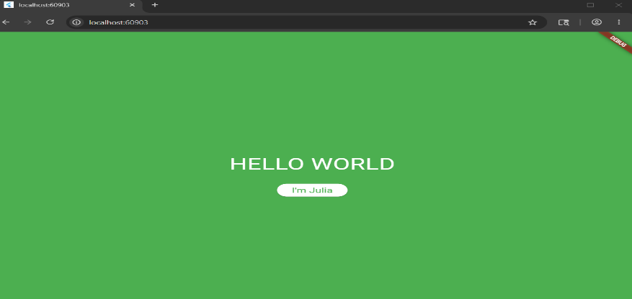

Assignment: New app with different features from hello world app

Code
Fig 5:
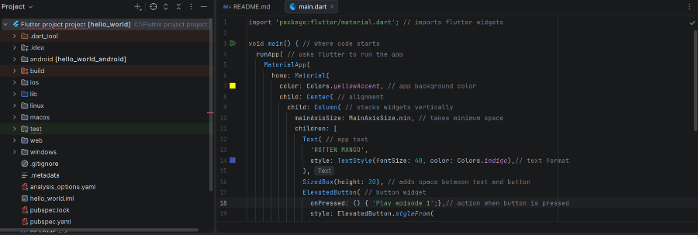

Output:
Fig 4:
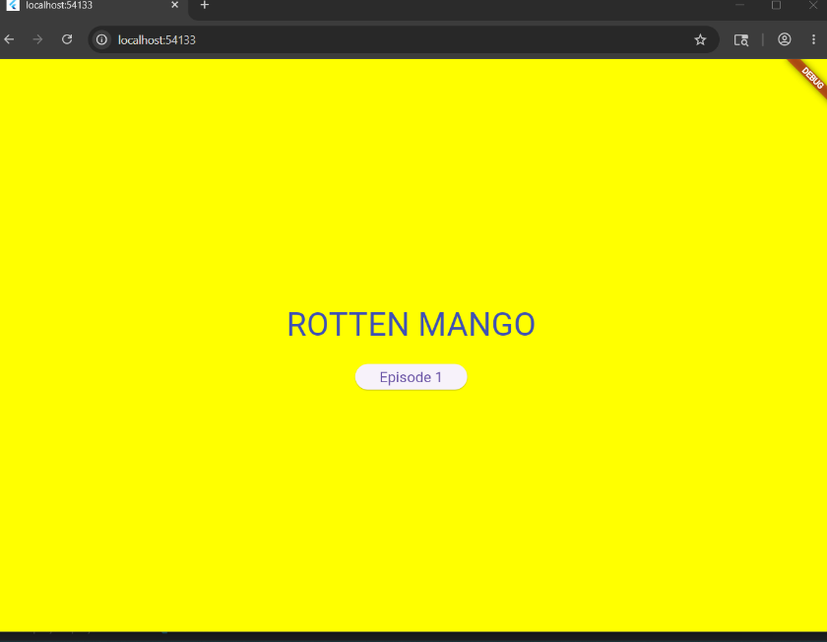

Tools/Software Used
- Android studio
- Web Chrome

Personal Reflection
There are two different ways for installing ide’s, through command line or through visiting the official website of the IDE. For more understanding, the latter is the better opption

Week 2: Mobile Development Environment

Development of the mini-Student management app:

Code:
Main.dart code- connects all the screens for easy navigation
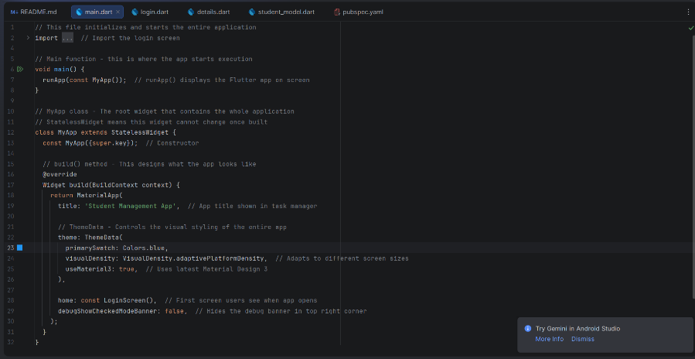
Login.dart- where users enter credentials
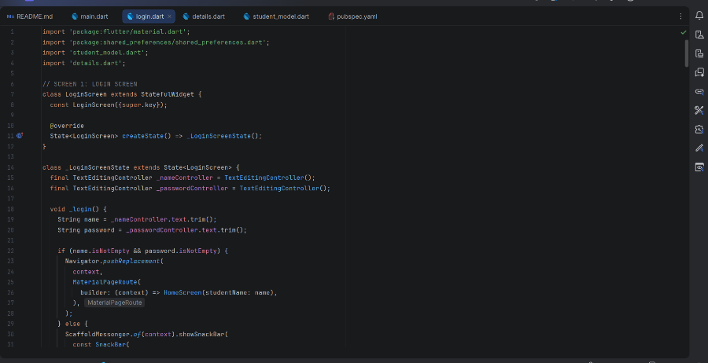

Details.dart- displays saved records
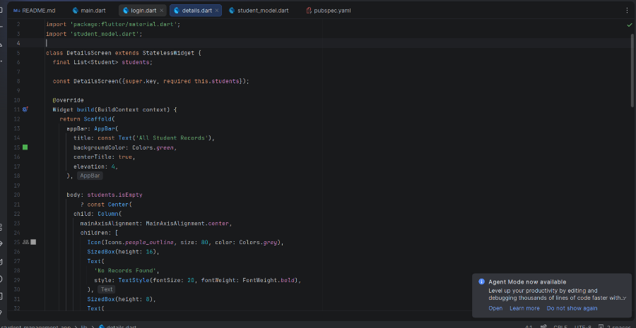
Pubsec.yaml- where all dependancies are input
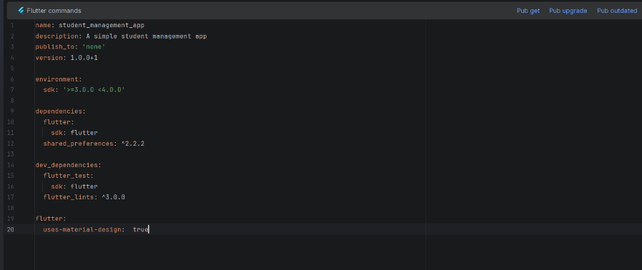

Output:
Log in Page- allows users to input credentials to access records
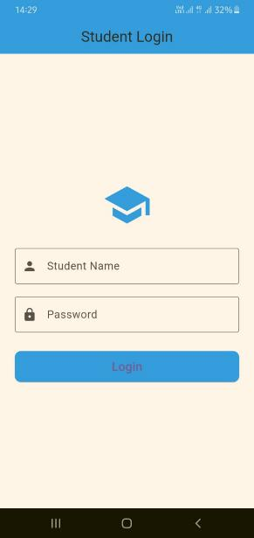
Record editing page- allows the user to manipulate the records they intent to store
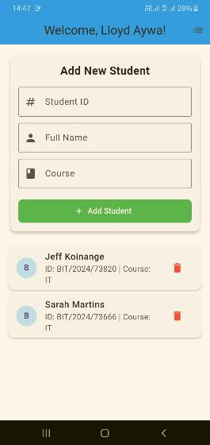
Record list page- it showcases a list of student records saved in the app
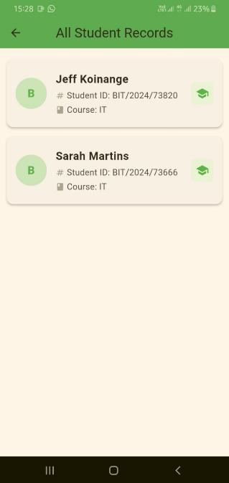

Tools /Software Used:
- Android studio
- Flutter
- Android phone

Personal Reflection
Flutter is an easy to use software because developers can import all the widgets ( buttons and icons) through one line making development effortless

Week 3: User Interface Design

UI Design
Using Figma to develop the interface design of the app, Shredded squad, a fitness app tracking and logging user information.
Splash screen
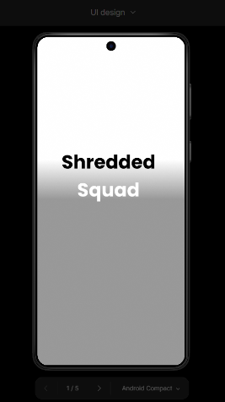
Log in screen
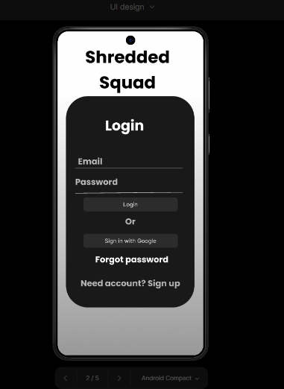
Dashboard screen
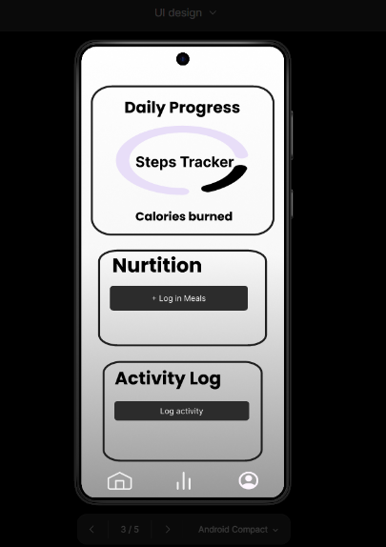
Progress and statistics screen
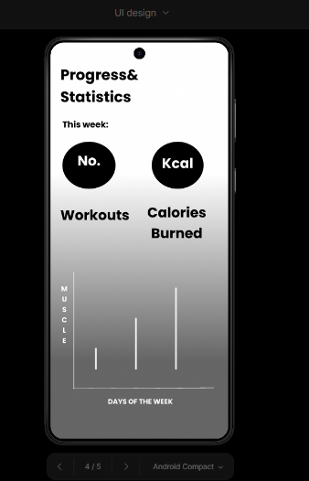

Profile screen
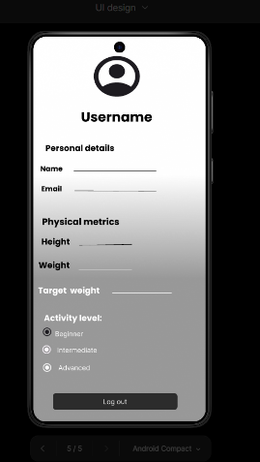

Code
Main.dart -wires he whole app together
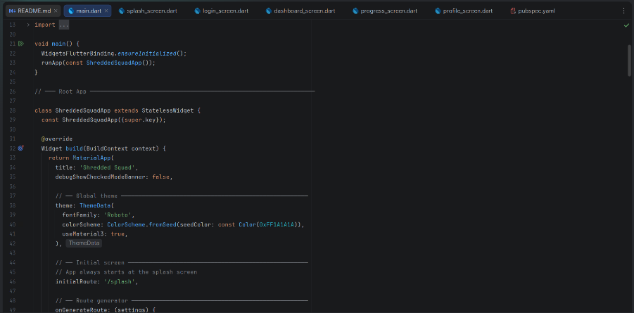

Splash_screen.dart – code to display the splash screen
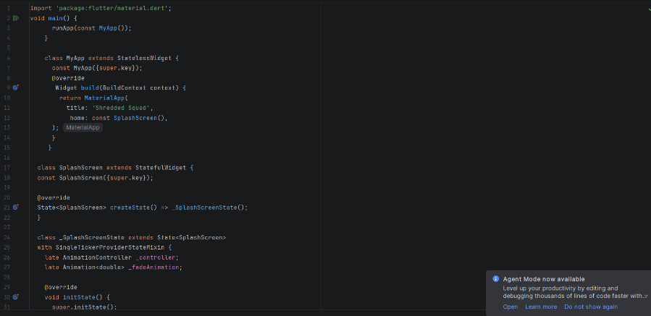
Login_screen.dart – code to develop the login screen
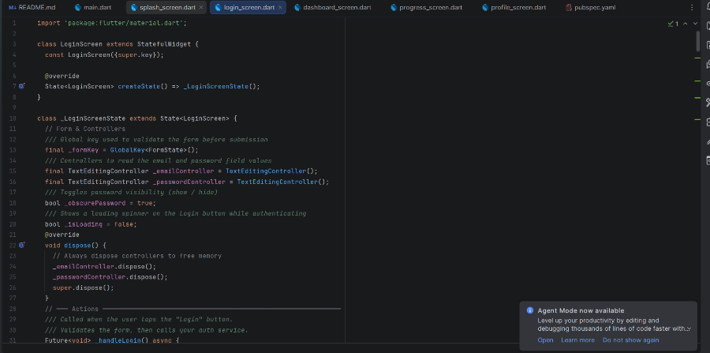

Dashboard-screen.dart – development code for the dashboard screen
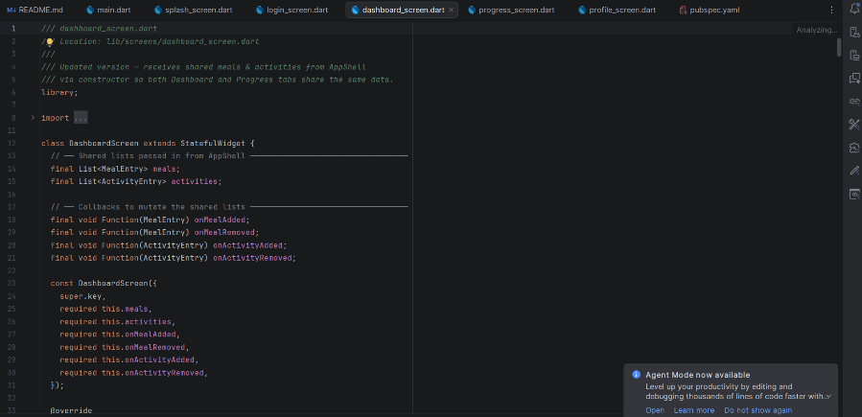
Progress-screen.dart- file code to develop the statistics and progress screen
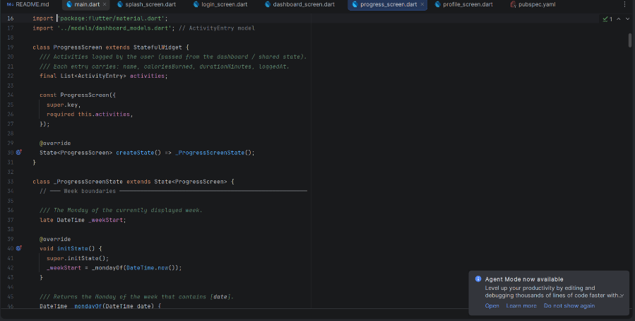

Profile-screen.dart- code for the profile screen development
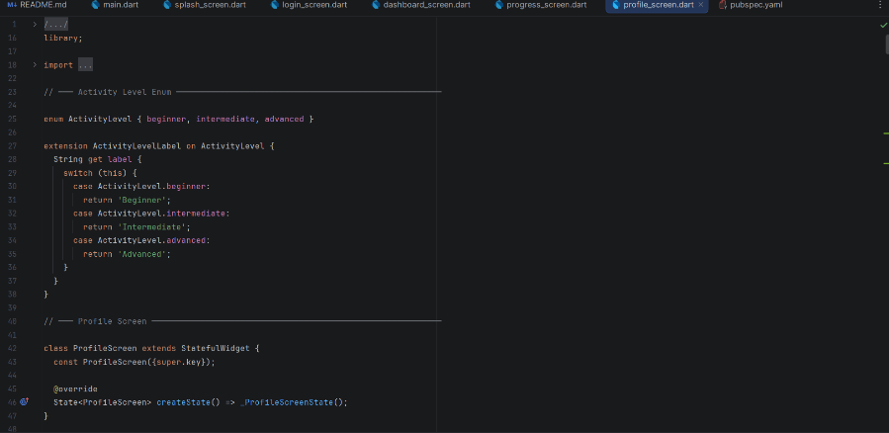

Output
Introduction page- showcases the app’s logo as an introduction of the app
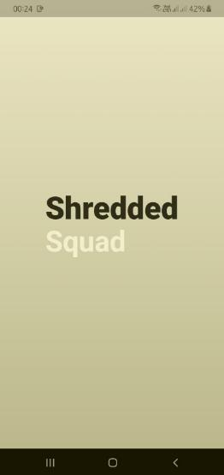

Login page- a page where the user enters their credentials to access the app’s functionalities
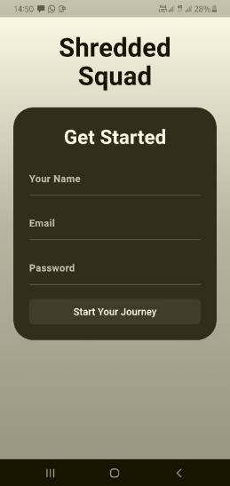
Dashboard/home page- display user name and profile, showing all the capabilities of the app
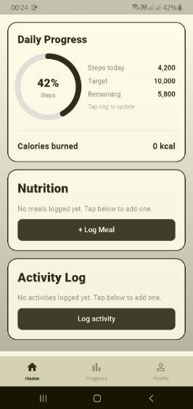
Statistics page- allows the user to track their progress over time through the graph bar and the number of calories they burn through the course of the week
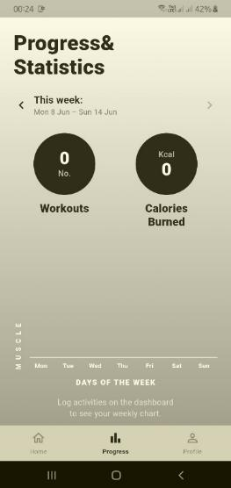
Profile page – allows users to edit their profile by logging their weight , uploading their profile photos and logging out of the app
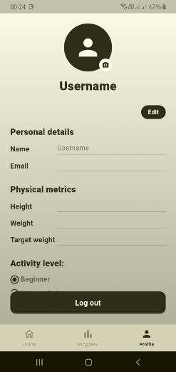

Tools/software Used
- Android Studio
- Flutter
- Android phone
- Flutter commands

Personal reflection
UI design is essential in mobile application development to avoid digression of developers towards out of scope things.

Week 4: Data Management

Entity Record Management
This week focused on implementing event handling and user interaction within the Shredded Squad fitness app by building a full entity record management module for managing Users Personal Records via CRUD operations backed in SQLite.

Code
Database_helper.dart- initializes the database, creates the pr table, and exposes insert (), getAll (), search (), update () and delete () methods
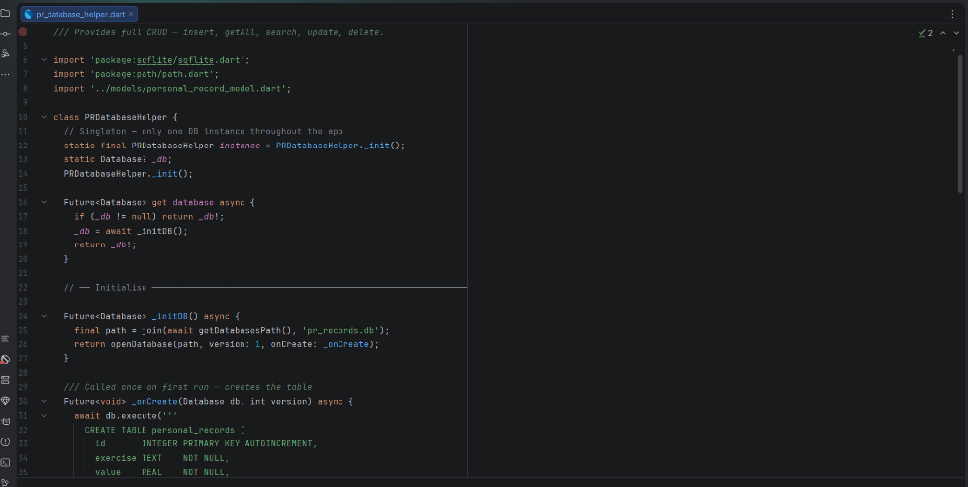
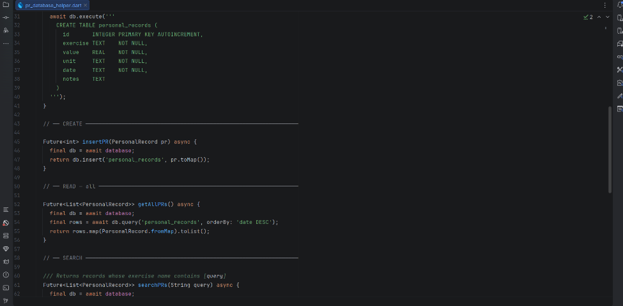
Personal_record_model.dart - Pr data class with toMap() and fromMap() serialisation methods for SQLite row conversion
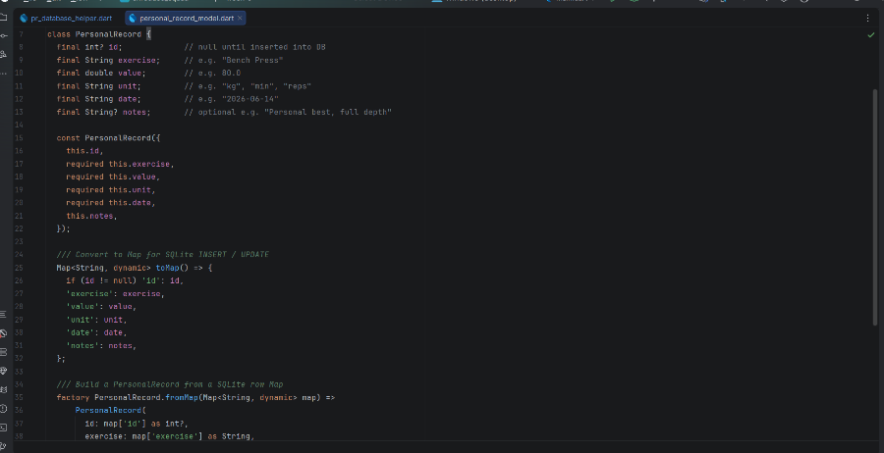
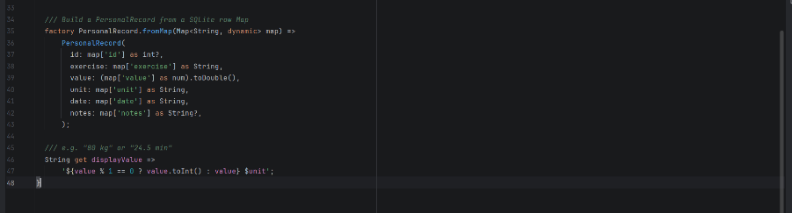

Personal_record_screen.dart -Full UI for the Members tab
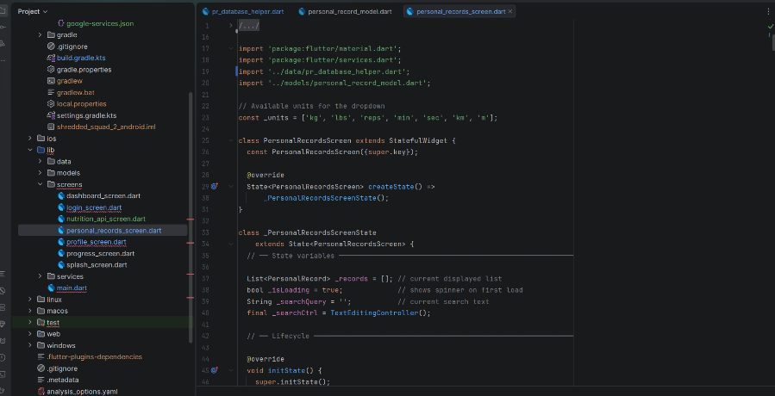
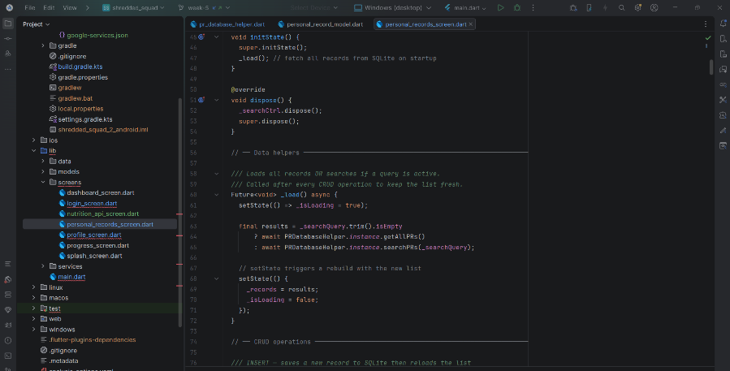
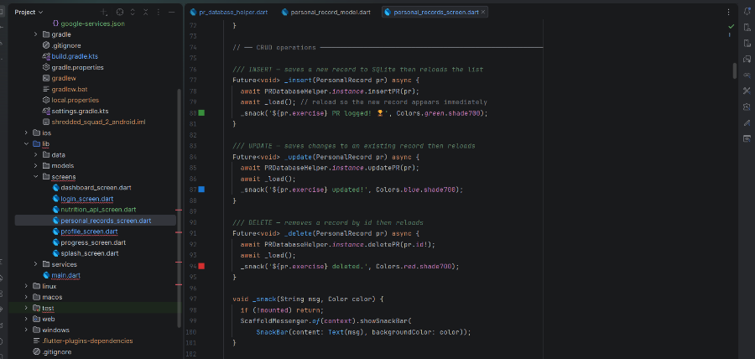

Output
Personal records display screen – Once records are logged in, they are saved in the database and displayed in this screen
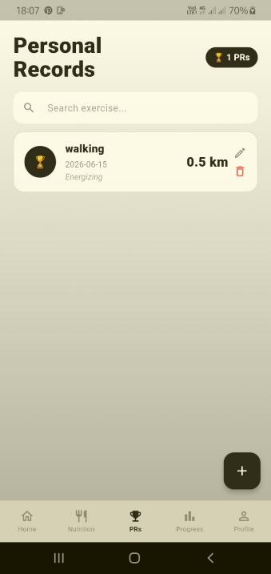

Search element- This is where users can search for PR records located in the storage in a search bar
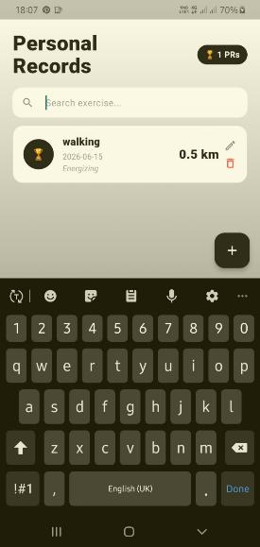
Records insertion- is done by taping the + widget to log in new records
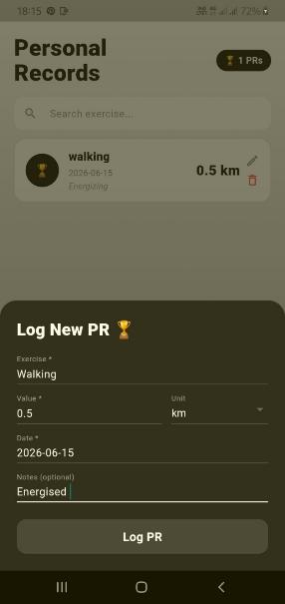
Records Update- Where saved records are edited, denoted by the pencil widget
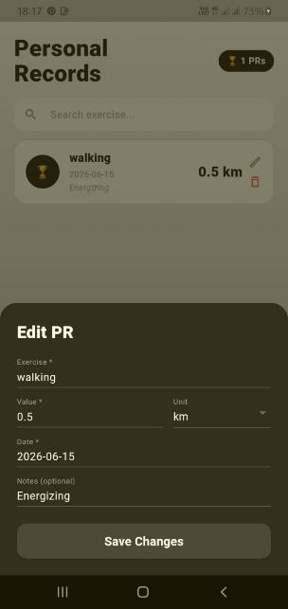

Tools/Software Used
- Android Studio
- Flutter
- sqflite package (SQLite for Flutter)
- path package (database file path resolution)
- Android Phone

Personal Reflection
Implementing CRUD operations with SQLite in Flutter demonstrated how persistent local data storage works in mobile applications. Live search using the LIKE SQL operator showed how database queries can be tied directly to UI events for a seamless, responsive interaction.

Week 5: Networking and APIs

API
Implementation of a public API , a food/nutrition API that fetches data from a public API to log in meals while effectively calculating Calories.

Code
Nutrition_API_screen- displays fetched data from public API
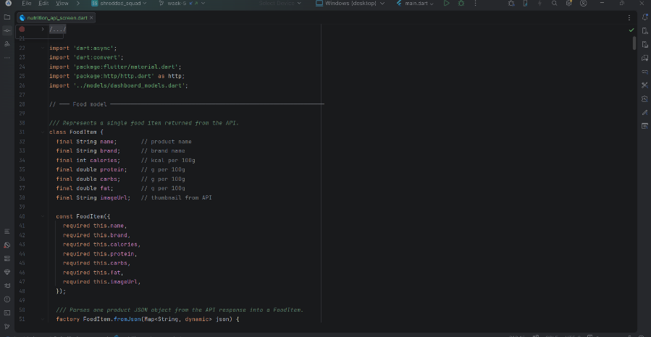
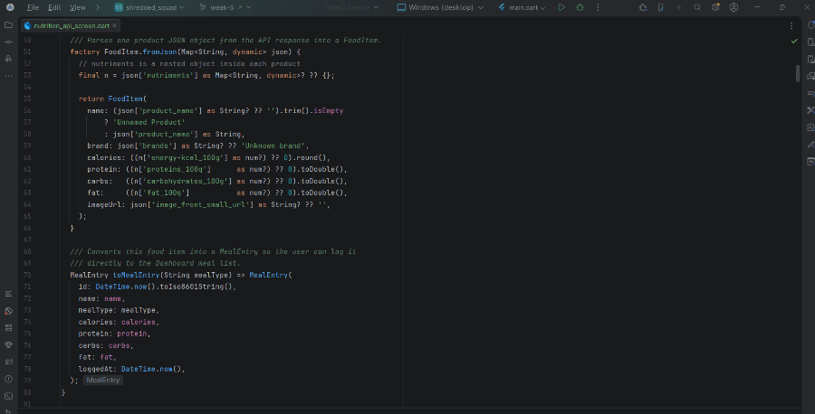
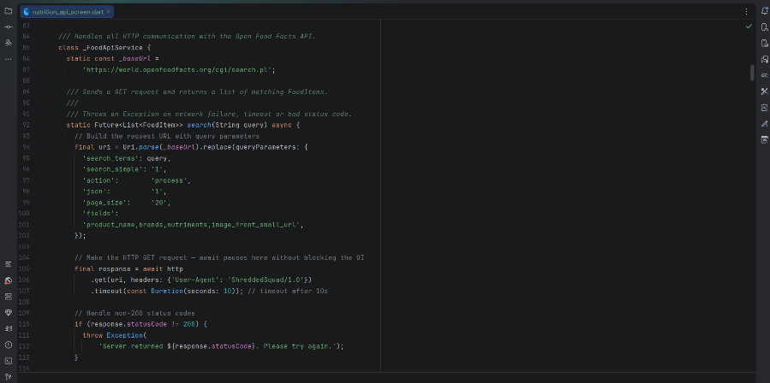

Output
Output generated if users try to access app with no internet connection
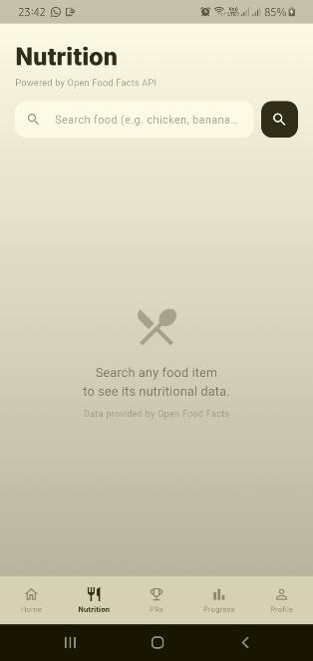

Tools Used
- Android studio
- Flutter
- Android phone
- Public API- open food facts

Personal reflection
Handling inconsistent portion sizes was a challenge—I normalized entries using gram-based logic. This improved my understanding of data cleaning.

Week 6: Networking

Internet connectivity
In the Shredded Squad app, internet connection is vital as it allows users to access the data sourced from the API for logging in nutrition details and keep information upto date.

Code
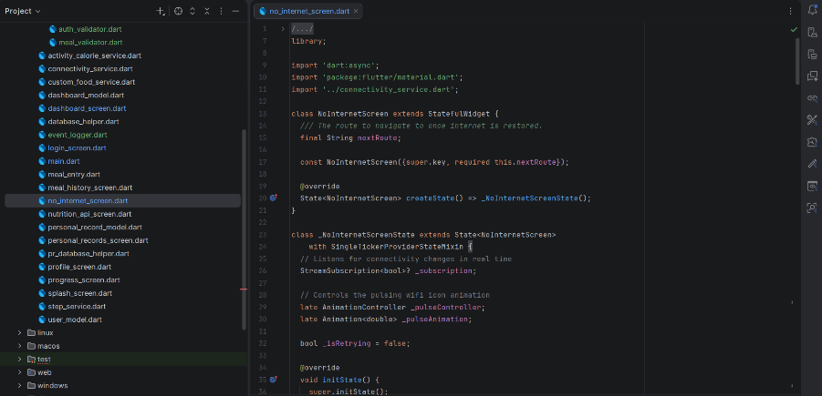
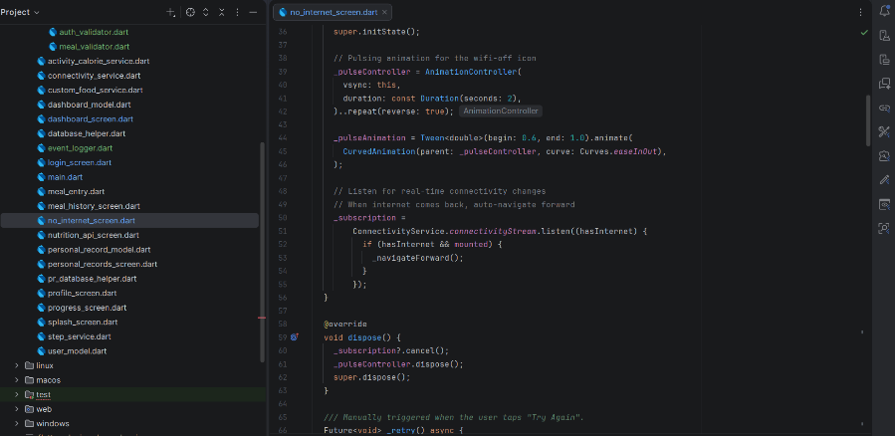
The code ensures that the app cannot proceed without internet connection.

Output
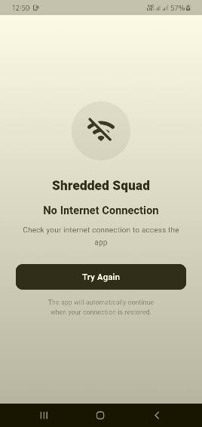

Tools used
- Android phone
- Flutter
- Android studio
- Connection dependencies

Personal reflections
Connectivity is a vital tool necessary for accessing data from the internet. I faced gradle sync issues overcome by code reconstruction

Week 7: Data storage and Database integration in mobile applications

Data storage
The storage method chosen is SQLite due to its lightweight, embedded, zero-configuration local persistence, guaranteeing offline operation without server overhead.
The normalized structure for users is linked via UID; meals/activities/PRs with auto-increment IDs).

Code
This code ensures users details and uploads are stored in SQLite for users’ progress

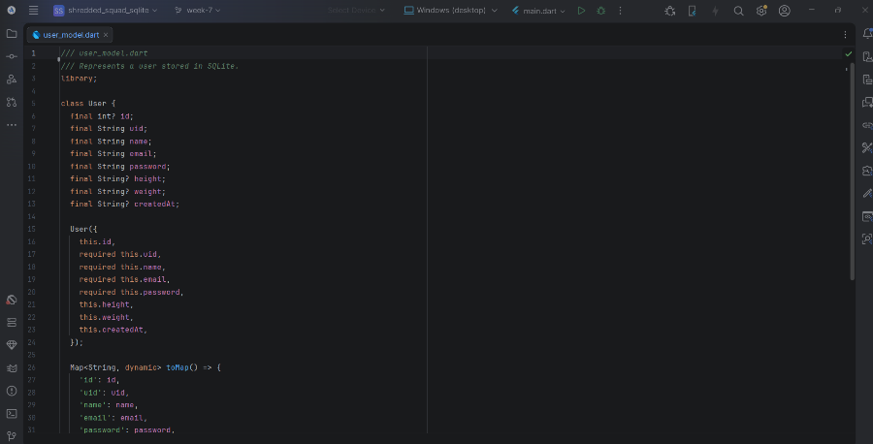

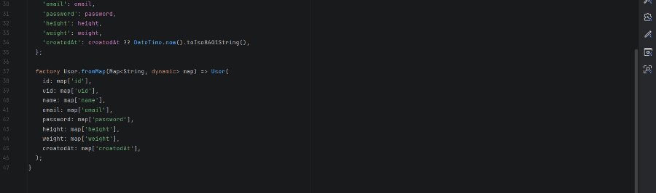

Output
User authenticated locally via SQLite query
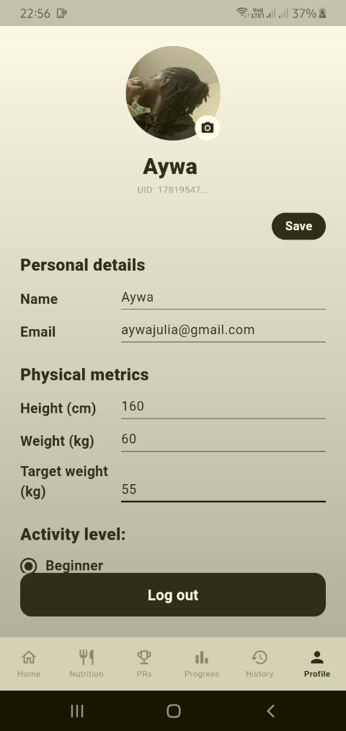

Meals are stored permanently in local database
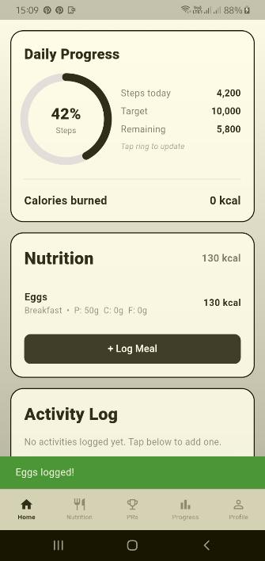

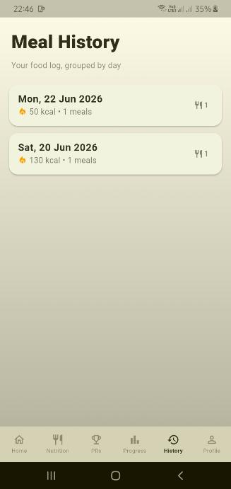
Tools used
- Android phone
- Android studio
- Flutter
- SQLite

Personal Reflection
Local-first apps offer user reliability and user friendliness. Firebase plugins were causing gradle sync issues.

Week 8: Handling User input and events
This week focused on separating gesture and keyboard logic into reusable OOP classes for cleaner, more maintainable mobile interactions via:

Input
- Adding an Eventlogger service that logs every user interaction with a timestamp. Providing a real-time debug trail and satisfies the logging events.
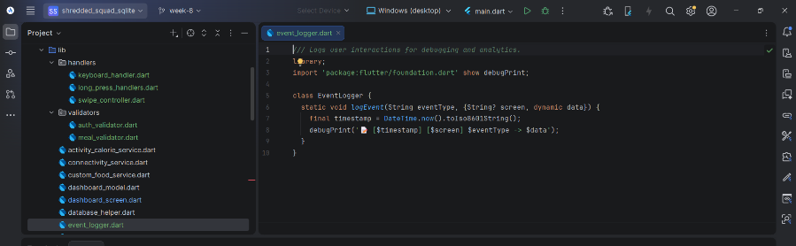
This is the output displaying the timestamps of the action performed.
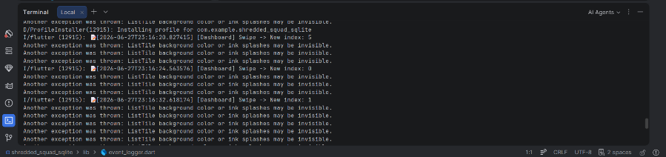

- Adding swipecontroller that manages tab navigation via horizontal swipe gestures. Listens to left/right swipes on the between the main tabs
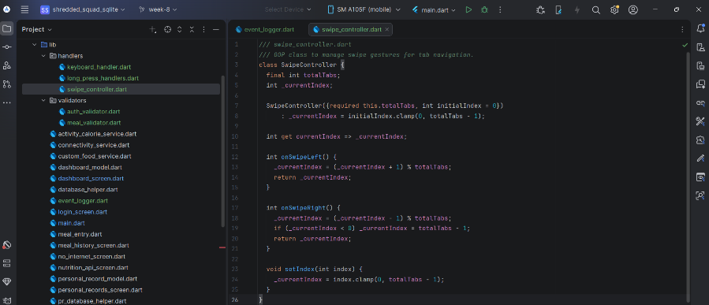
The terminal output below represents the swipe logins in which the indexes represent the taps from the splash (0 index) to the screen swiped to i.e index 4, 3 and 2 below that is the, Meal history, progress and Personal records screens
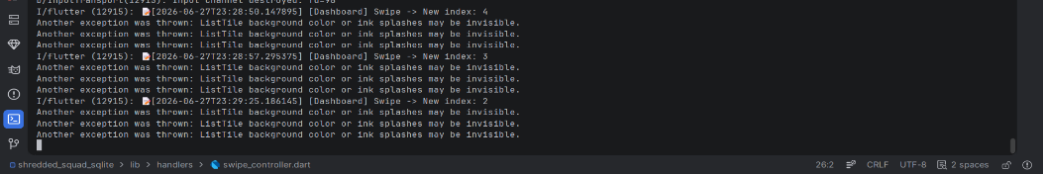
- Adding the KeyboardActionHandler that eases user login by allowing the pressing event via the key enter to login after credential input.
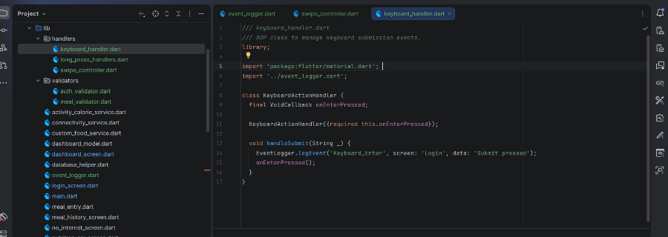
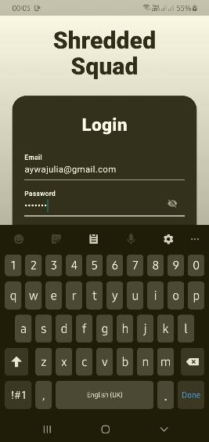The done key on the keyboard allows users to login.

- Adding the LongPressHandler to display a context menu when a user long-presses a meal item on the Dashboard. The menu offers Delete Meal and View Details options, keeping the UI uncluttered while still providing powerful actions.

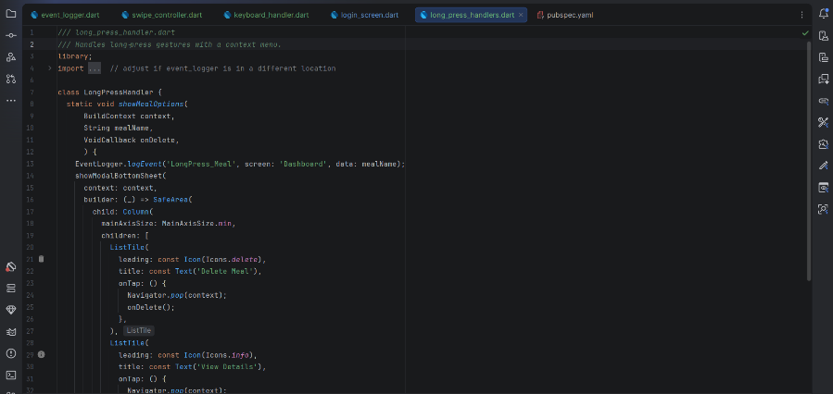
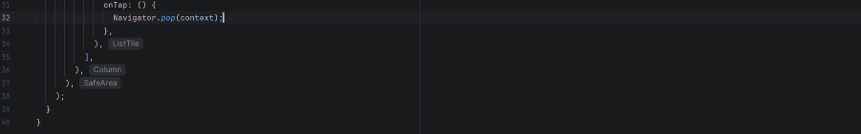
The output after long pressing the nutrition tab on the dashboard
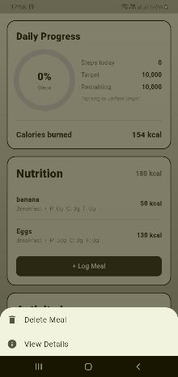
Tools Used
- Android phone
- Fultter
Android studio

Personal reflection
Adding moving gestures and keyboard logic into OOP classes made the app modular, maintainable, and responsive and user friendly

Week 9: Device Features and Sensors

Same as week 1

Week 10: Notifications and Background Services

Same as week 1

Week 11: Mobile Security

Same as week 1

Week 12: Testing and Debugging

Same as week 1

Week 13: Application Deployment

Same as week 1

Week 14: Final Project Presentation

Same as week 1

Semester Project Tracking

Project Title

Project Objectives

Project Requirements

Development Milestones

Testing Results

Lessons Learned

Future Improvements

End of Semester Reflection

Summary of Skills Acquired

Most Interesting Topic

Major Challenges Faced

How Challenges Were Overcome

Professional Growth Achieved

Overall Course Experience

Final Approval
Student Name: __________________________
Student Signature: ______________________
Date: _________________________________
Lecturer Name: _________________________
Lecturer Remarks: _____________________
Date: _________________________________

